A Musician Is…
Violin and Viola lessons
720-840-7760
nikki@raffertyhome.com

Studio Philosophy
Nicole Rafferty’s studio operates under two predominate philosophies; Dr. Suzuki’s principle that Every Child Can and F.M Alexander’s body neuromuscular reeducation technique. The Suzuki principle asserts music is an intrinsic part of every human being’s nature and that if a student desires to learn, it is the responsibility of the teacher and parent to aid them in the learning process. Alexander’s principles are used in the lesson to encourage the development of healthy postural and mental habits.

Private Lessons
The Student/ Parent may choose between lesson lengths of 30 min, 45 min, or an 1hr once every week. If the Student/Parent would like to schedule lessons for more than once per week provisions can be made for such an arrangement. Lessons are taught during the school year and during the summer.

Teacher Responsibilities
The teacher is responsible for aiding the student, to the best of her abilities, in the development of their musical and technical abilities regarding the violin. As well as, to create a safe and secure environment in which the student feels secure to make mistakes and ask questions. The teacher may also aid the student with their posture by physically helping the student by touching their neck, back, arms, or fingers.

Parent Responsibilities
For younger students (age 3-13) a parent is strongly encouraged to read Dr. Suzuki’s book Nurtured by Love. For these younger students, the parent is also required to attend lessons and take notes. In addition, it is expected that the parent will help the student practice while at home.

It is important for the parent to remember that a student’s attitude towards practicing will vary depending on the student’s mood, as well as, the parent’s attitude toward helping them practice. Practicing is difficult but encouraging a healthy attitude towards practicing through example and encouragement will help the student develop persistence and a good work ethic in other areas of the student’s life.

Student Responsibilities
A student is required to come to lessons on time, with all their music, and equipment (violin, bow, shoulder rest, and foot chart).

A student is also required to come prepared for lessons. Meaning, that they have practiced the previous week and are in a ready mental state to work.

Attendance
Attendance is required every week unless the teacher or the parent/student cancels lessons.

Cancellation Policy
Both the teacher and Parent/Student are required to cancel lessons within 12 hours of the upcoming lesson. If the student does not inform the teacher in a timely fashion that they will not be attending their lesson the student is required to pay for that missed lesson.
Makeup lessons are strongly encouraged however, if a student would prefer not to make the lesson up there is a $5 charge. This is due to the cost of booking the studios facilities.

Makeup Lessons
If the student misses a lesson without informing the teacher prior to the lesson being missed, the teacher is not required to makeup that lesson.

If the teacher needs to cancel a lesson prior to the 12 hour notice they are required to makeup that lesson in a timely fashion.

All makeup lessons must be made up within two weeks of the initial lesson date. Otherwise, the student forfeits the lesson.

Termination of Lessons
If a student would like to discontinue lessons, studio policy requires at least one month’s notice before the last lesson.

Payment
Payment is required at the beginning of each lesson or at the beginning of each month. The studio accepts check, direct deposit or cash. Payment is also expected for the use of the MusicFirst classroom in the amount of $15 per month. Group classes may be opted into each month.

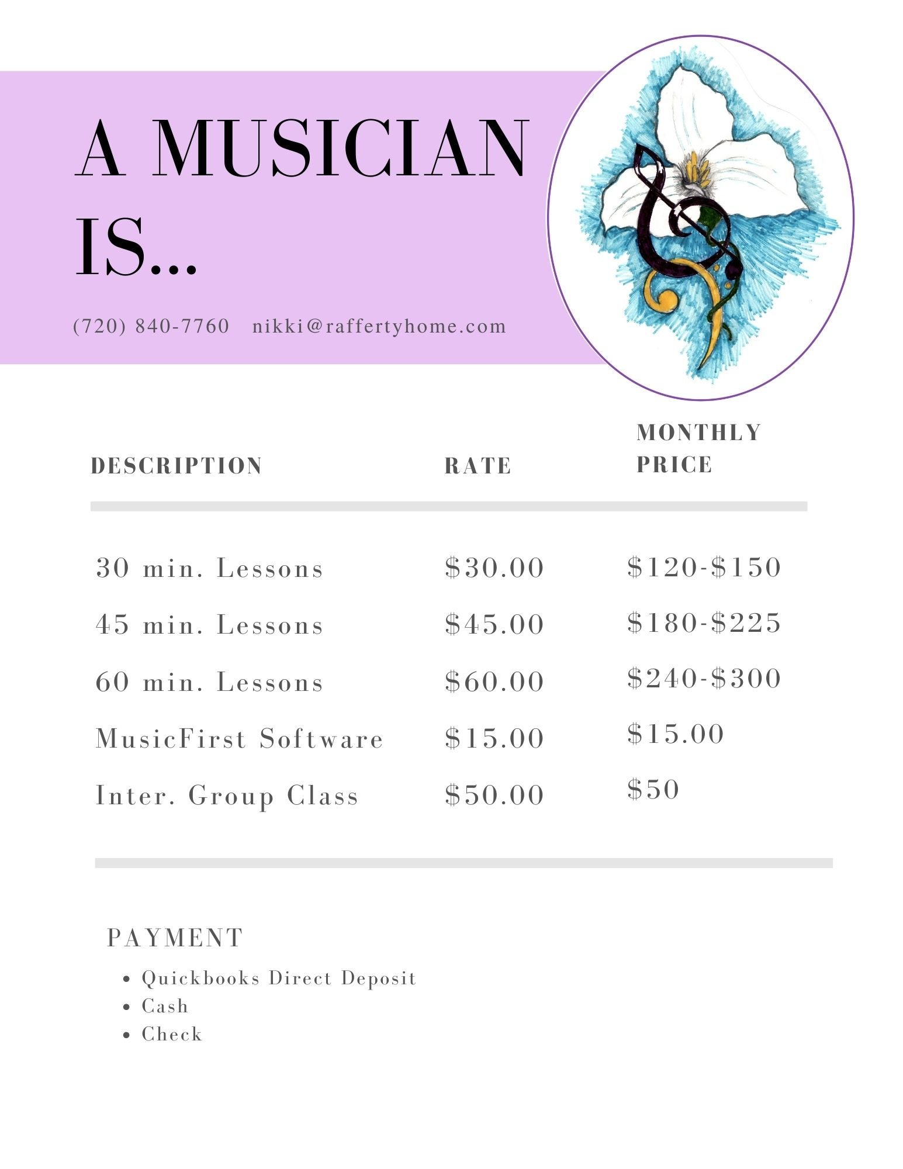

I, ___________________________ Understand an Agree with all the terms of Nicole Rafferty’s Violin Lesson contract.

Student:____________________________________ Date:__________________

Parent:_____________________________________ Date:__________________
Contact Information

Parent’s Name___________________________________________

Parent’s Phone Number___________________________

Parent’s Email address ________________________________

Parent’s Email address_________________________________

Student’s Name__________________________________________

Student’s Phone Number (optional) ___________________________________

Student Height__________________________

Student Age______________ Years of Previous Experience____

Photograph & Video Release Form

I ___________________________ hereby grant permission to the rights of my child,_________________________’s, likeness and sound of my child’s voice or other personal information (ex. name, appearance, etc.) as recorded on audio or video tape without payment or any other consideration. We understand that my child’s image may be edited, copied, exhibited, published or distributed and waive the right to inspect or approve the finished product wherein my child’s likeness appears. Additionally, my child and I waive any right to royalties or other compensation arising or related to the use of their image or recording. My child and I also understand that this material may be used in diverse educational settings within an unrestricted geographic area.

Photographic, audio or video recordings may be used for the following purposes:
- Advertising/ promotional material
- educational presentations or courses
- informational presentations
- on-line educational courses
- educational videos

By signing this release I understand this permission signifies that photographic or video recordings of my child may be electronically displayed via the Internet or in the public educational setting.

I will be consulted about the use of the photographs or video recording for any purpose other than those listed above.

There is no time limit on the validity of this release nor is there any geographic limitation on where these materials may be distributed.

I recognize that I reserve the right to have the photographic, audio or video recordings of my child removed at any time. In order, to have the photographic, audio or audio recording I must contact Nicole Rafferty either vie email or phone and provide at least one week for my request to be completed. After making the request Nicole Rafferty will remove all photographic, audio or video recordings that she personally uploaded or used for educational or promotional purposes.

Finally, I observe that any previous verbal consent provided for the use of my child’s photographic, audio or video image recordings is valid and is subject to the same conditions discussed in this consent form.

By signing this form I acknowledge that I have completely read and fully understand the above release and agree to be bound thereby. I hereby release any and all claims against Nicole Rafferty or organization utilizing this material for educational/promotional purposes.

Full Name___________________________________________________

Street Address/P.O. Box________________________________________

City ________________________________________________________

Prov/Postal Code/Zip Code______________________________________

Phone ___________________________ Fax _______________________

Email Address________________________________________________

Signature____________________________ Date____________________________

If this release is obtained from a presenter under the age of 19, then the signature of that presenter’s parent or legal guardian is also required.

Parent’s Signature_____________________ Date____________________________

